Issues and Improvements

# Menus

## Text

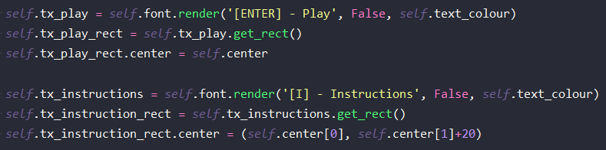The menus for the game have lots of text objects. Creating each of these objects takes a significant amount of code which is cumbersome to write out and takes too much space. The code for two text objects is below:

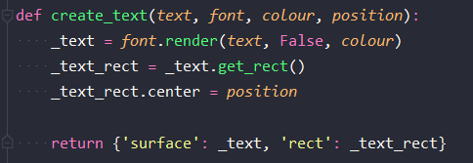To make this easier I wrote a function that would take parameters for the text and then return the text surface with its rect.

## Own Surface

## Buttons

The event queue gets cleared when it is read so I cant go through it in the button update method.

### Relative mouse position in child rect